Project (v1.1)

Released: 19 Feb 19 (Tue, Week 7)

Deadline: 5 Mar (Tue, Week 9) 11:30pm
Server will start accepting submissions on 22 Feb 19.
Always check “Announcements” at red.smu.edu.sg for errata and project-related information

General Instructions:
- There are 3 fun questions in this project to be attempted individually.
- This assignment constitutes 10% of your final grade for this course.

Q1: Loaded Die Simulation

Find out about how to generate a random integer in Python; you may use the randint() or randrange() functions from the standard Python library.

Requirement:
Write a function called r6_loaded() that generates a random integer from 1 to 6 (both inclusive) except that the number 1 appears 50% of the time, and the remaining numbers (2-5) each appear 10% of the time. This simulates a loaded 6-sided die used by tricksters that shows “1” half of the time.
You are also not allowed to use any 3rd-party Python library. You may use p1_main.py to check if your function has been written correctly, but do not submit this file.

Q2: Special Value of a Matrix

A matrix is a table of integers. By definition, the special value (SV) of a particular cell in a matrix is calculated like this:
SV of a cell = (numerical value in the cell) +
(SV of cell below, if it exists) +
(SV of cell to the right, if it exists)
Consider this 3x4 matrix, and study how the SV of four cells are calculated:
 | 0 | 1 | 2 | 3
0 | 3 | 0 | 2 | 18
1 | -1 | 1 | 3 | 4
2 | -2 | -3 | 18 | 7

SV(2, 3) = 7 + 0 + 0 ← (2, 3) has no cell below it or to its right.
= 7
SV(1,3) = 4 + SV(2, 3) + 0 ← (1, 3) has no cell to its right
= 4 + 7 + 0 = 11
SV(2, 2) = 18 + 0 + SV(2, 3) ← (2,2) has no cell below it
= 18 + 0 + 7 = 25
SV(1, 2) = 3 + SV(2,2) + SV(1,3)
= 3 + 25 + 11 = 39

If you work it out manually, the SV of the upper-left-most cell (0, 0) is 216:
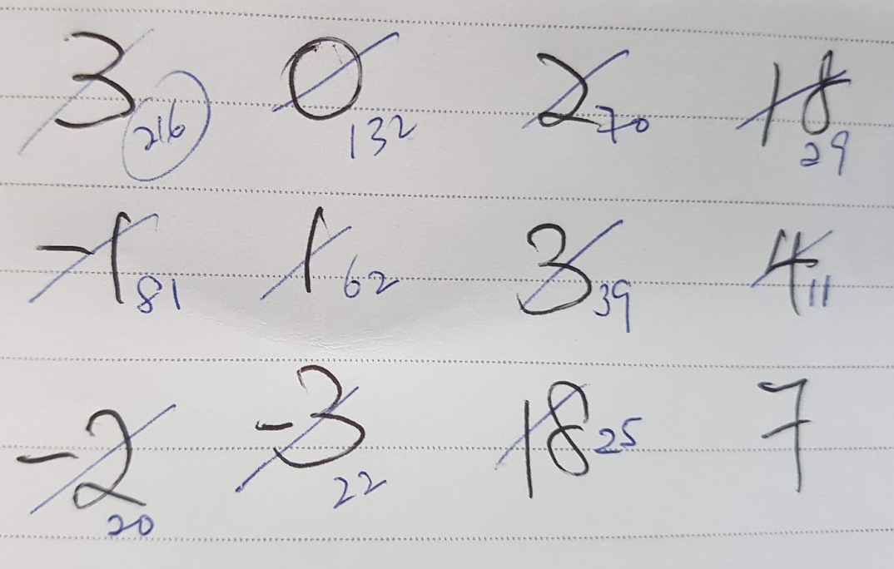

The SV of a matrix, by definition, is the SV of the upper-left-most cell of that matrix (0, 0). A matrix can be represented by a 2D list of integers in Python. The matrix above is represented like this:
m = [[3, 0, 2, 18],
[-1, 1, 3, 4],
[-2, -3, 18, 7]]

Requirements:
- Write a function called sv_iterative(m) that takes in a matrix (m), and returns the SV of that matrix. This function solves the problem without recursion.
- Write a function called sv_recursive(m) that takes in a matrix (m), and returns the SV of that matrix. This function must use recursion to solve the problem.
Both sv_iterative and sv_recursive should return the same answers when the same matrix is passed in. You may use p2a/b_main.py to check if your functions have been written correctly, but do not submit these files.

Q3: Fun with Sums

Given a list of integers and a target integer, you want to compute all the possible groups (consisting of 2 or 3 members) from the list that sum up to the target. You want the list of groups with the indices of the 2 or 3 numbers.

For example, consider this list (nums) and target (t):
nums = [3, 0, 1, 0, -1, -2, 0]
t = 0
There will be 9 answers (4 with 2-members only, and 5 with 3-members only):
[3, 0, 1, 0, -1, -2, 0] → [1, 3] (2 members)
[3, 0, 1, 0, -1, -2, 0] → [1, 6] (2 members)
[3, 0, 1, 0, -1, -2, 0] → [2, 4] (2 members)
[3, 0, 1, 0, -1, -2, 0] → [3, 6] (2 members)
[3, 0, 1, 0, -1, -2, 0] → [0, 4, 5] (3 members)
[3, 0, 1, 0, -1, -2, 0] → [1, 3, 6] (3 members)
[3, 0, 1, 0, -1, -2, 0] → [1, 2, 4] (3 members)
[3, 0, 1, 0, -1, -2, 0] → [2, 3, 4] (3 members)
[3, 0, 1, 0, -1, -2, 0] → [2, 4, 6] (3 members)
The list on the right of the arrow shows the indices of the selected members that add up to t.

Note that the answer [1, 3] is the same as [3, 1], so you should only return one of these two.

Requirement:
Write a function called ttsum(nums, t) that takes in a list of integers (nums) and a target integer (t), and returns a 2D list of all answers. Remember that your solution should not contain duplicate answers.

Example:
nums = [3, 0, 1, 0, -1, -2, 0]
t = 0
ttsum(nums, t) may return [[1, 3], [1, 6], [2, 4], [3, 6], [0, 4, 5], [1, 3, 6], [1, 2, 4], [2, 3, 4], [2, 4, 6]]

Other solutions with the elements in a different order are acceptable. For example, the following are considered identical answers:
- [[1, 3], [0, 4, 5], [9, 8]]
- [[3, 1], [9, 8], [0, 4, 5]]
- [[5, 0, 4], [8, 9], [1, 3]]

You may use p3_main.py to check if your function has been written correctly, but do not submit this file.

Requirements for Written Report:
- You are required to submit ONE written report (PDF or Word format) for this assignment to eLearn by the same deadline.
- Explain your algorithm adopted to approach all 3 questions. If possible, compute the time complexity of your algorithm and show how this value is derived. You will be given credit for clarity of explanation, novelty of approach and evidence of analytical thinking. Use diagrams and examples where relevant.
- The algorithms described in your report must be synchronized with the latest version of code submitted to red.
- Your report must not be longer than 2 pages (excluding the cover page, references and appendices, if any). Content beyond 2 pages may not be marked.
- Plagiarism is an offence. If you have used an idea from any source or obtained help from any person, you must acknowledge all sources and assistance in a reference section. Include URLs if relevant.

Scoring
This assignment is worth 10% of your final IS103 grade:
- Algorithm: Q1 (2%)
- Algorithm: Q2a/b (4%)
- Algorithm: Q3 (2%)
- Written report (2%)

Your algorithm will be scored in 2 ways:
- correctness: it works as required and returns correct solutions for different test cases. Each function must each complete running within a fixed amount of time on the server. The time limit given will be posted at red. Additional test cases will be executed on the server after your deadline.
- speed: the time taken for your function to complete. You may be given credit for algorithms that have a good time complexity (and hence takes lesser time to complete for a large data set). Speed is only considered if your solution is correct. The “time taken” on the scoreboard at red is merely a guide; after the deadline, your code may be executed using different data sets to derive your time taken. There may not be a significant variation in speed for certain questions, in which case, all correct solutions will receive the same score.
“Quality” will not be taken into consideration for these questions. You will always see a quality score of “1.0” on the server if your solution is correct.

For all questions, an attempt is better than no submission. Attempts submitted to eLearn (together with your written report) may be manually marked if they do not show up as “correct” at red.

To Submit:

- Always refer to the “Announcements” at http://red.smu.edu.sg; clarifications, additional test cases and bug reports will be posted there.
- Submit to red:
  - You need to submit q1.py, q2a.py, q2b.py and q3.py to red for automatic marking.
  - You can submit your solutions to red as many times as you wish, but the final submission on the deadline will be taken as your final submission.
  - Do check all 4 scoreboards after your last submission to check that your name is on the scoreboards (your name will appear if you have submitted a correct answer).
- Submit to eLearn (Assignments):
  - Written report (Word or PDF)
  - Identical copies of your final versions of q1, q2a, q2b, and q3.py
- Late submissions will be penalized:
  - <1 hour late: penalty of 10%, <24 hours late: penalty of 25%
  - Submissions later than 24 hours will not be marked (you will get zero for that question).
  - red will be closed for submission at the deadline. If you are submitting anything late, you will have to contact Mok (telegram: @Mokkie) to enable submission at the server.

~End

